Strategic Planning Team
Maidstone Borough Council
Maidstone House
King Street
Maidstone
Kent
ME15 6JQ

Dear Sir/ Madam
RE: | Maidstone Local Plan - Call for Sites Consultation Representation against Land East of Dairy Lane, Chainhurst (572871, 147809)
We, Anthony and Astrid Robson, XXXX welcome the opportunity to respond to the Maidstone Local Plan Call for Sites consultation and wish to object to the promotion of the above site, C4S (005), for development under allocation Policy of the Maidstone Borough Council Gypsy, Traveller, and Travelling Showpeople Plan (‘GTTS’) currently under consultation.
Should this letter be made publicly available, we request that the email addresses and any residential addresses included below are redacted prior to publication. We note from your email that only names are made publicly available, so we trust that this request is acceptable.
Land East of Dairy Lane, Chainhurst (‘the Site’) should not be taken forward within the emerging MBCGTTS as it is not suitable, not appropriately located, and does not represent an achievable or deliverable option for sustainable development.
We have reviewed the SHELAA relating to the Site and set out below several inaccuracies we believe are included, which we believe give a false impression of the Site’s development potential.

Local and National Planning Policy Context

National Level
The National Planning Policy Framework (NPPF) sets out the Government’s planning policies for England and sets out how these should be applied by local planning authorities. The latest version of the NPPF was revised on 12 December 2024 following consultation on wider planning reforms, with minor corrections issued in February 2025. Under the current NPPF, there is no dedicated traveller policy section, however the Planning Policy for Traveller Sites (PPTS), updated December 2024, is formally linked to the NPPF and must be applied alongside it.
A consultation is currently being held on the NPPF until 10 March 2026 (“the draft NPPF”). Policies are intended to become material considerations from the day of publication (Annex 1 of the draft NPPF). The revised NPPF is currently expected to be published and come into effect by June/July 2026, and so it is likely a new Local Plan and/or future application would be considered against this. Whilst the draft NPPF policies hold limited weight at this stage, they show the direction of travel for national planning policy, identifying a specific policy (HO12) directly relevant to the travelling community and more generally encouraging new residential-led development in areas where there is unmet need and which is sustainably located regarding existing settlements.
The Planning Policy for Traveller Sites (December 2024) sets out the Government’s dedicated planning framework for traveller accommodation, requiring fair and equal treatment of the travelling community, recognition of traditional nomadic lifestyles, and an obligation on local authorities to assess need and plan for adequate site provision. It outlines the Government’s aims to increase the supply of lawful traveller pitches, reduce unauthorised encampments, and ensure that travellers can access essential services such as education, health, welfare and employment.

Local Level
In accordance with the Planning Policy for Traveller Sites, the emerging Maidstone Borough Council Gypsy, Traveller, and Travelling Showpeople Plan (‘GTTS Plan’) (November 2025) to support the Regulation 18 consultation outlines accommodation needs of Gypsies, Travellers and Travelling Showpeople for the period 2023–2040, and sets out a spatial strategy that allocates sites and broad locations to meet those needs, and includes both strategic and non-strategic development management policies to support their delivery.
The GTTS Policy TR1 (2) outlines that development within the countryside should be avoided wherever possible so as to promote truly sustainable development and to minimise harmful impacts on the countryside. Emerging Policy TR6, also sets out the criteria for exception sites, of which part c) requires development is sustainably located, with reasonable access to facilities and services in the nearest settlement. Part d) of TR6 also states development should be made safely accessible to and from the public highway by all vehicles using the site.
Emerging Policy TR5 states that accommodation on non-allocated sites must follow set criteria, which includes:
- TR5 (b) - Local services, in particular school, health and shopping facilities, are accessible from the site preferably on foot, by cycle or on public transport;
- TR5 (d) - The development would not result in signiﬁcant harm to the landscape and character of the area … With regard to (i) Local landscape character;
- TR5 (e) - The site can be safely accessed to and from the highway by all vehicles using the site, including emergency services and service/maintenance vehicles;
- TR5 (f) - The site is not located in an area at risk from ﬂooding..; and
- TR5 (g) - The ecological impact of the development has been assessed through appropriate survey.
Despite the above policies, the GTTS Plan identifies the Site as allocation (005) – Dairy Lane, Chainhurst under proposed policy C4S. This proposed allocation will support planning permission for up to three permanent pitches on the basis that safe access is proved via Dairy Lane, site specific constraints are considered, an appropriate landscaping scheme provided and the undertaking of a Phase 1 habitat survey.
It is evident that this allocation fails to meet the relevant local and national policy requirements, both existing and emerging, to justify its inclusion. Consequently, the Site cannot be regarded as deliverable, as it is neither suitable, nor achievable for development, as demonstrated in the sections below.

Marden parish area, which includes the Site, has a Marden Neighbourhood Plan. Policy In7 relates to Housing for Gypsies and Travellers. The policy clearly states that sites will be supported “which provide adequate amenities for occupants and which do not result in unacceptable harm to the amenities of existing residents in the vicinity of the site, the character of the countryside or the biodiversity of the wider area”.

As we set out below, the Site does not meet Policy In7. The impact of the proposed allocation on the Site will have a negative effect on the amenities of existing residents, the character of the landscape/countryside and biodiversity.

Suitability

Sustainable location

As identified by the Council in the Site’s (Ref. 054) assessment during preparation of the current Local Plan, it was identified that it did not benefit from any bus stops within 400 metres, nor does it have access to a GP surgery, primary school, or convenience store within an 800-metre walking distance. Whilst the services could be argued to be within a reasonable cycling distance, the route is along small, tight lanes, which would not be suitable to all but the most experienced cyclists and even then, only at certain times of the year when there is sufficient daylight.

Public transport connections are particularly limited, with journey times exceeding 30 minutes to the nearest town centre and more than one hour to the nearest hospital. In addition, there is only one service in the morning and afternoon during the weekdays, and no services at the weekends or during school holidays. To achieve even a basic level of sustainability, substantial mitigation measures would be required, including diverting existing bus services to route via Dairy Lane, providing new pedestrian footways, creating safe crossing points to public transport facilities, and increasing the frequency of bus services. These interventions would, however, be unfeasible due to the need for third-party land and the insufficient scale of the development to support enhanced public transport provision. Consequently, the Council has previously concluded that the Site’s isolated and unsustainable location renders it unsuitable for development, a position reflected in the current Local Plan, and one we trust the Council will continue to recognise and uphold.

Although the Site lies near existing residential properties, its relationship with the wider settlement pattern does not represent a sustainable location for growth. The significant transport constraints remain unchanged from the Council’s earlier assessment. The Site continues to rely solely on Dairy Lane, a narrow, single-width rural road that cannot safely accommodate two-way traffic, pedestrian or cycle movements, resulting in safety concerns, and fundamentally unsustainable travel patterns.

As with any proposal for residential-led development, whether intended for the Gypsy and Travelling Community or wider community, reliance on unsustainable transport options should not be encouraged. Granting development at this Site as an exception on the basis of the intended occupants would not justify further outward expansion, particularly where a site demonstrably fails to align with the principles of sustainable development of the current and emerging NPPF or the objectives of the Local Development Plan and thus proposed emerging policies TR5 (b) and TR6 (c) of the GTTS Plan.

Most notably, the Site’s inherently unsustainable location directly conflicts with the aims of draft NPPF Policy HO12 (1a and 1b), which requires traveller sites to provide a settled base that limits long-distance travel and associated environmental impacts, while recognising the sustainability benefits of traditional living and working patterns. The policy also expects sites to be situated where residents, especially children, have convenient access to education, health, and welfare services. Furthermore, as the Site lies within the countryside and outside any defined settlement boundary, draft NPPF Policy S5 is also relevant. This policy allows development outside settlements only where it meets an evidenced unmet need for Traveller, or Travelling Show people accommodation, but only where the proposal also meets the criteria set out in Policy HO12. Although these policies have not yet been formally adopted, it reflects the Government’s overarching direction of travel for national planning policy, and it is against these emerging principles that any new Local Plan, including proposed Policy TR1 (2) where it relates to development in the Countryside, will ultimately be assessed and with which the proposed Site allocation would not accord.

Given these issues, we object to the inclusion of this Site in the emerging Gypsy, Traveller, and Travelling Showpeople Plan. Providing any form of residential-led development at this Site would undermine efficient land-use planning, and fail to deliver development that meets the environmental, social, and transport-related expectations of sustainable growth.

Access and highways

The Site does not benefit from sustainable vehicular or pedestrian access via Dairy Lane. At present, the lane measures approximately 3 metres in width, which is significantly below Kent County Council’s Highway Design Standard of 5.5 metres for an adoptable access road. It is therefore anticipated that Dairy Lane’s current state could not adequately support larger vehicle, emergency vehicle or caravan movements. In addition, the existing access arrangement does not accommodate pedestrian or cycle movements, rendering the Site unsustainably located for future users to reach nearby public transport services. On this basis, development of the Site would fail to meet the requirements of paragraph 115 of the NPPF, which seeks to ensure that development promotes sustainable transport, delivering safe and suitable access for all users.

In the Council’s previous assessment of this Site pursuant to the 2019 Call for Sites (Ref. 054), it was concluded that it was unsuitable due to inadequate access and poor connectivity to essential services and thus not taken forward in the adopted Local Plan. As the circumstances underpinning that conclusion have not changed, we request that the Council maintain its position that the Site is not appropriate for allocation or development by way of its unsafe access, which is fundamentally outlined as a necessity of emerging Policies TR5 (e) and TR6 (d).

Landscape and Visual Impact

The Maidstone Landscape Capacity Study: Sensitivity Assessment (January 2015) identifies the Site as lying within the Staplehurst Low Weald Landscape Character Area, part of the wider Low Weald character type. The landscape condition of this area is assessed as Good, with a High landscape sensitivity, resulting in an overall management recommendation to Conserve.

Figure 1 demonstrates the extensive long-range views across the Site which, due to its flat topography and elevation compared to the surrounding area, allows clear visibility of the Greensand Ridge to the north, designated as a Landscape of Local Value. The figure also highlights the significant visibility of the Site from residential properties along its southern and eastern boundaries on Dairy Lane, indicating that any future development would have a marked and potentially harmful effect on the visual amenity currently experienced by these residents. This is contrary to the statement submitted by the landowner.

Existing Local Plan Policy LPRSP14(A)(1)(b) seeks to safeguard positive landscape character, including the protection of Landscapes of Local Value, and to prevent significant adverse impacts arising from development, in line with the requirements of paragraph 187 of the NPPF. This approach is also reflected in emerging Policy TR5 (d(i)). The sensitivity of the landscape, coupled with the Site’s high degree of visual exposure, therefore strongly indicates that development here would conflict with emerging and established local and national policy objectives.
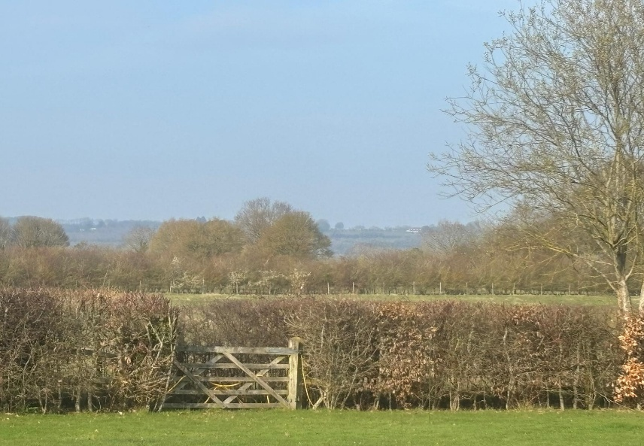
Figure 1: North facing view of Site

The proposed policy for this site proposes a landscaping scheme to try to mitigate visual impacts. However, this will artificially subdivide this site, appearing incongruous in the landscape and further harming the landscape pattern of this mature rural setting.

Heritage

There are several heritage assets nearby including six Grade II listed buildings. The “Site of oast at Reed Place Farm, Dairy Lane, Marden”, is recorded in the KCC Historic Environment Record. It has a clear open view of the Site.

To the south is Dairy Farm (Dairy House), a farmstead and homestead also recorded in the KCC Historic Environment Record. Again, there is a close relationship between this historic asset and the Site where there are interlinked views.

Ecology

In the Council’s previous assessment of this Site (Ref. 054, which was not taken forward in the now-adopted Local Plan), it was acknowledged that woodland lies immediately adjacent to the eastern boundary, as well as mature hedgerows. The surrounding area also contains several ponds, and (possibly) Great Crested Newts have been recorded locally. There is therefore a clear likelihood that protected species, including bats, dormice and breeding birds, may be present within or near the Site. As local residents, we can attest to the regular presence of bats, slow worms, and newts in the vicinity.

Given these observations, it is unreasonable for the landowner to assert that the Site does not support protected species without having undertaken any specialist ecological survey work and given the habitats surrounding the site. This is particularly pertinent as equine-grazed fields are known to increase species richness, promote flowering plant diversity, and support a range of invertebrates, thereby enhancing the habitat potential for protected wildlife. In the absence of robust ecological evidence prepared by a qualified ecologist, such claims cannot be considered justified and as such do not accord with emerging policy TR5 (g), and wider national policy.

Flood Risk

Whilst the Site lies within Flood Zone 1, the surrounding area is effectively encircled by Flood Zones 2 and 3, representing areas of medium and high probability of flooding. Furthermore, surface water flood risk has been identified as encroaching onto the Site over time, particularly in the south-eastern and western corners. This demonstrates that, although the Site may not currently be at high risk, due consideration must be given to potential changes in flood risk over the lifetime of the development, in accordance with paragraph 175 of the NPPF. Of particular concern, at times of flood, which are prevalent in this location, the site will be inaccessible, due to the Site being on land that is effectively an ‘island’ (see EA flood map below).

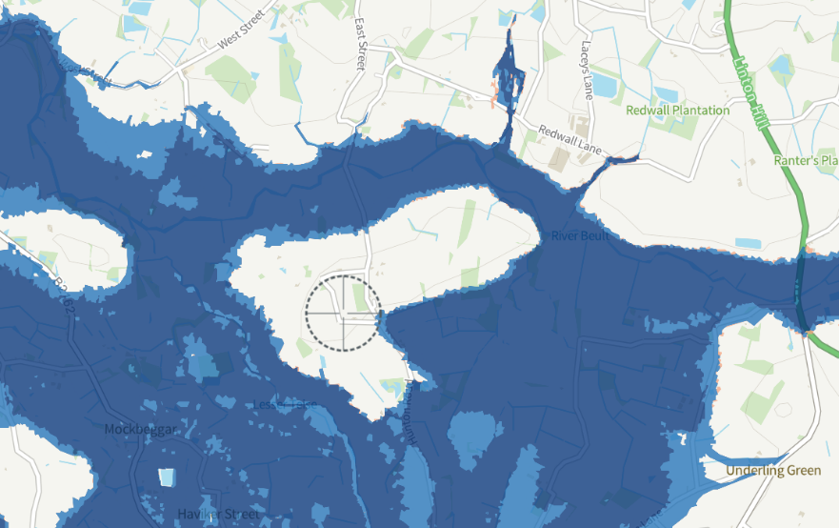

In the Council’s previous assessment of this Site (Ref. 054, which was not taken forward in the adopted Local Plan), it was noted that a drainage ditch is likely to be present. As such, an appropriate assessment would be required to determine how surface water should be managed. This important consideration has not been addressed in the current submission, so at present the Site would not accord with emerging Policy TR5 (D), thus making it unsuitable for allocated development.

Achievable
The site submission fails to demonstrate that any specialist advice has been considered in respect of landscape and visual impact, ecology, flood risk, or highways. As a result, the submission makes an unsupported assertion that the Site can achievably be developed, despite the absence of any detailed understanding of site-specific constraints, potential abnormal costs, or associated viability implications. Furthermore, the landowner appears to have given no consideration to any preparatory works that would be required to make the Site suitable for development, instead claiming that no such preparation would be necessary before construction could begin. This reflects a significant lack of awareness and an underestimation of the technical evidence required from relevant specialist disciplines to demonstrate that any future development, particularly one as important as residential-led development, can demonstrate sustainable development in accordance with the economic, social, and environmental objectives set out in paragraph 8 of the NPPF.
In addition, any future development would necessitate access improvements to comply with Kent County Council’s Highway Design Standards. This would include the widening of Dairy Lane to ensure it is suitable for use by future Site users, as well as the provision of a public footpath. Achieving this would require land outside of the landowner’s control. It is therefore unreasonable for the submission to claim that the Site is available to deliver development immediately.

Closure
Overall, the Site represents an unsuitable development opportunity due to the number and severity of constraints identified. Whilst we acknowledge the need for sites to accommodate both Travelling communities and wider residential uses, we are confident that more sustainable and deliverable alternatives exist in closer proximity to Marden. Consequently, we do not support the inclusion of the Dairy Lane, Chainhurst allocation (Policy C4S 005) in the GTTS.

Yours Sincerely,

Astrid Robson Anthony Robson

Here follows a list of neighbours who agree with the opinions expressed above.
The following residents of Chainhurst and the surrounding area strongly oppose the inclusion of the Dairy Lane site within Maidstone Borough Council’s Gypsy, Traveller and Travelling Showpeople Development Plan Document, for the reasons laid out in this letter:

