We write to formally comment on the draft Gypsy, Traveller and Travelling Showpeople Development Plan Document, with particular reference to draft allocation Policy C4S(008) – The Lodge, Water Lane, Bearsted.

We write to formally object to the inclusion of The Lodge site as a proposed allocation and that its application is withdrawn. Our concerns principally focus on the following issues:

- Highway safety – the inability for the site to be served by a safe vehicular access owing to significantly constrained visibility and no available mitigation.
- Sustainability – the inability for occupiers of the site to safely access local facilities by any sustainable means
- Landscape impact – the inability for the site to accommodate the development proposed whilst conserving and enhancing the nearby Kent Downs National Landscape , being a prominent site within its setting
- Deliverability – in the absence of a safe, deliverable access, the site fails the deliverability test and cannot be relied upon to make any contribution towards the Borough’s gypsy & traveller needs.

We now deal with each issue in more detail in turn below.

- Highway Safety
XXXXX the adjacent Bridge Farm. We also own the existing access and driveway from Water Lane which serves both Bridge Farm and The Lodge. Whilst The Lodge have a right of access across this driveway, this would not extend to any additional development at The Lodge site. Access to their land is detailed in their deeds as being via our driveway on our easterly boundary or, closer to Water Lane through a gate from our driveway on our northern boundary (as shown in the picture below). It is for this reason, we assume, that the site has been promoted based on a separate access to the north of the existing access, as that would be the only lawful physical means of accessing the site as a gypsy & traveller site. Whilst there is an historic field gate at this point onto Water Lane, this does not comprise an existing formal access point and until very recently, has been heavily overgrown and unusable (see Google Streetview images below) and was not used by the previous owners of The Lodge.
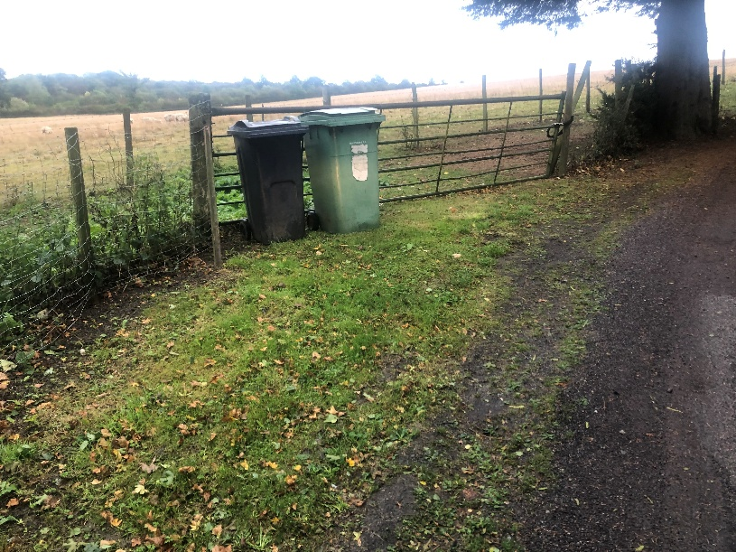
Access gate to The Lodges land from Bridge Farms driveway on Bridge Farms northern boundary (closest to Water Lane)
August 2021
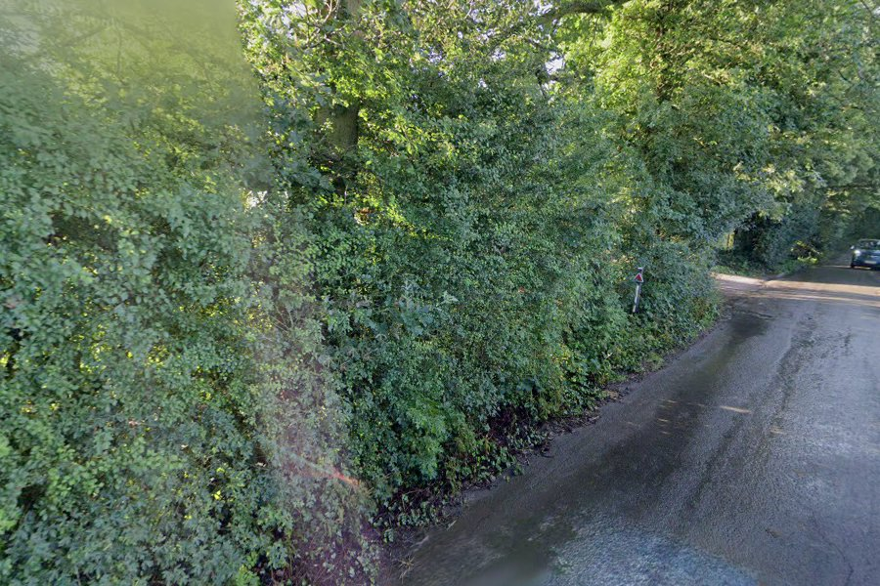

August 2012
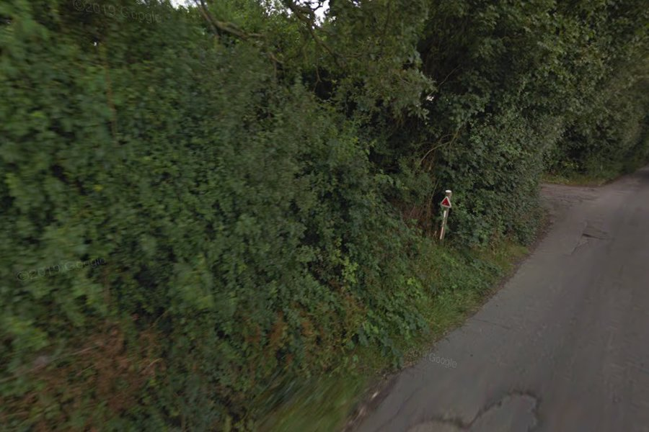
April 2009
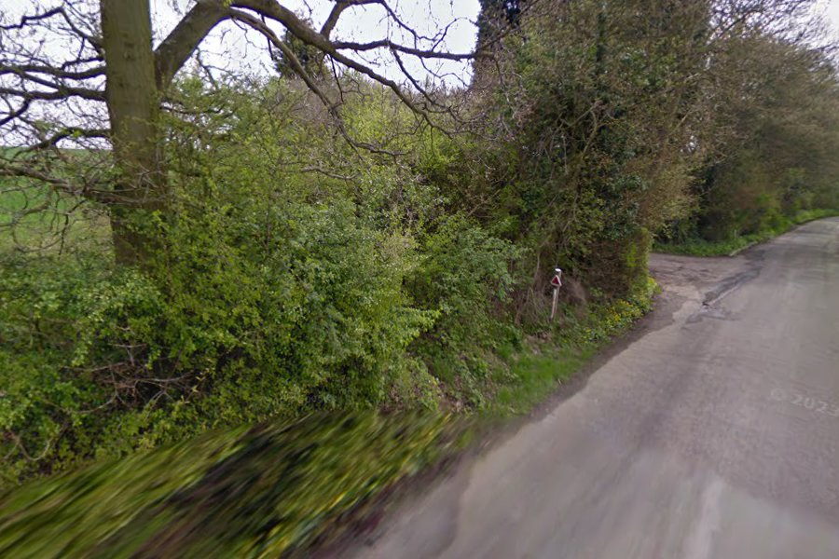

As the above illustrates, the proposed access has not historically been used to access the property in any meaningful way and therefore any assessment of the site as a potential allocation must reasonably be on the basis that a new access is required to be formed onto Water Lane, a narrow and undulating country lane subject to the national speed limit.
Having reviewed the available information and evidence base, it does not appear that any meaningful highways assessment of the proposed access has been carried out by either the site promoter/owner, Maidstone Borough Council as the Local Planning Authority, or Kent County Council in their capacity as the Highways Authority. In contrast, we have engaged with a qualified highways engineer who has advised on and helped produce the attached access plan, which has been produced and verified by on-site survey measurements.
When considering the potential access and its suitability and safety, the following constraints must be acknowledged and borne in mind.
- Ownership – the land in the ownership and control of The Lodge at this location is limited to a small stretch of frontage onto the highway, immediately north of the existing established access and driveway (which cannot lawfully be used to serve a gypsy traveller site and is outside the promoters’ ownership and control). Therefore, any assessment of the access and available visibility must only consider potential visibility splays which cross land in the promoter’s control or is public highway. This severely limits available visibility at this location.

- Trees and Tree Preservation Orders – to the immediate north of the existing and historic field gate at this location lies a mature tree which is subject to a Tree Preservation Order (no. 14 of 2007). This constrains the achievable visibility even further.

It is also noteworthy that the trees to the south of the Bridge Farm access along the Water Lane frontage are also subject to a group TPO (see image below showing TPOs to north and south of the proposed access taken from MBCs online mapping).
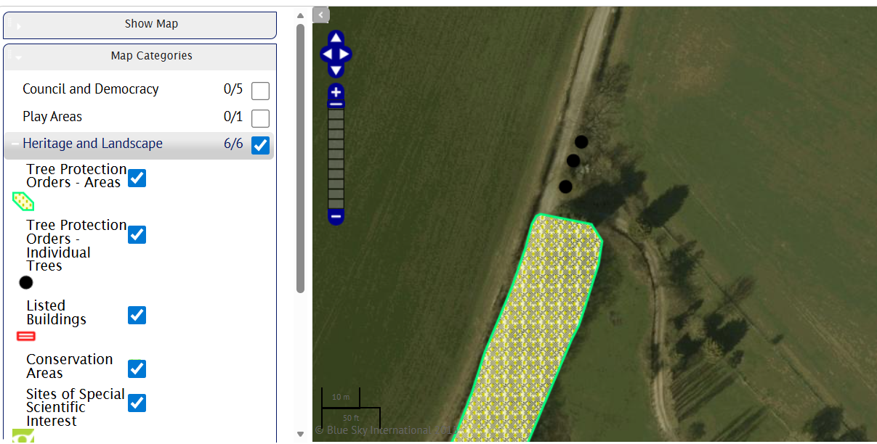

The supporting SLAA document does acknowledge the presence of these TPOs, but states “Amber - 4 TPOs to be considered through detailed assessment”. It is therefore evident that despite proposing an allocation, the impact of these TPOs has not been assessed in any detail to date.
Subject to planning, any access to the public highway would need approval from KCC highways likely via a vehicle crossover application. KCC guidance state that they will not support the removal of a tree to support a vehicle crossover application and all trees within 15m of where a dropped kerb is needed are to be considered as part of any application. KCC will also not accept any construction works within the root protection area of the tree, irrespective of any TPO.
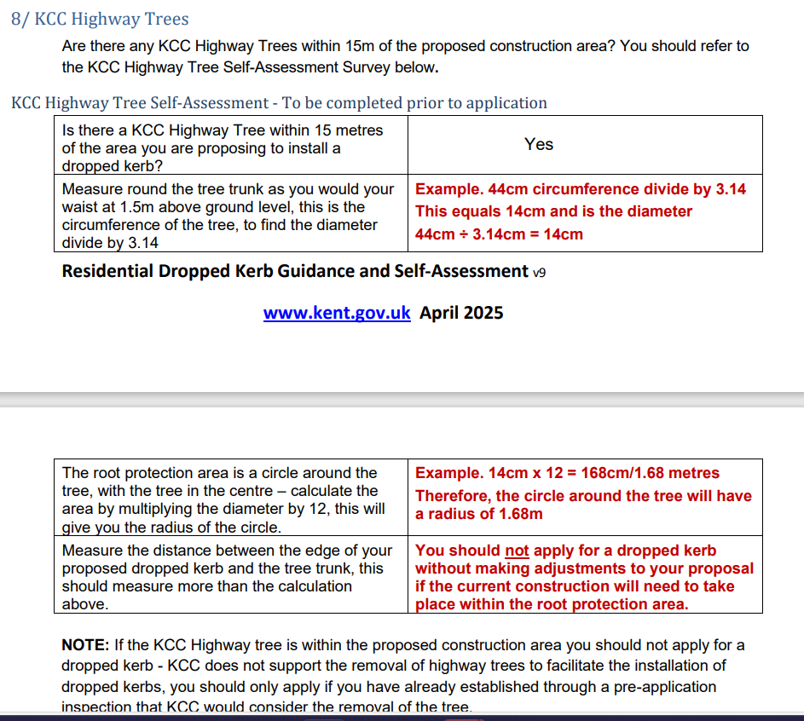
It is therefore clear that the existing trees represent a significant constraint and have not been given due consideration by the Council to date in their assessment of the site. The SLAA document acknowledges in its appraisal of the site that KCC as the local Highways Authority are yet to assess the site and will do so prior to Regulation 19. It is concerning that sites are being proposed by the Council at this Regulation 18c stage without their input given access and highway safety are such fundamental issues that go to the heart of suitability and deliverability. We urge the Council to engage with KCC Highways and provide them with the detail of this representation to assist in their own appraisal of the site and the proposed access.

- Speed Limit – at this location, Water Lane is subject to the national speed limit. No speed survey data has been provided by the site promoters that we are aware of and in the absence of this, the correct approach would be to design the access and the visibility splay requirements on the basis of 60mph.

- Surface Water Flooding – Water Lane (as the name would suggest) is subject to regular surface water flooding, which adds yet further hazards to highway safety and users of the road. This is confirmed by the Environment Agency surface water mapping (see extract below).

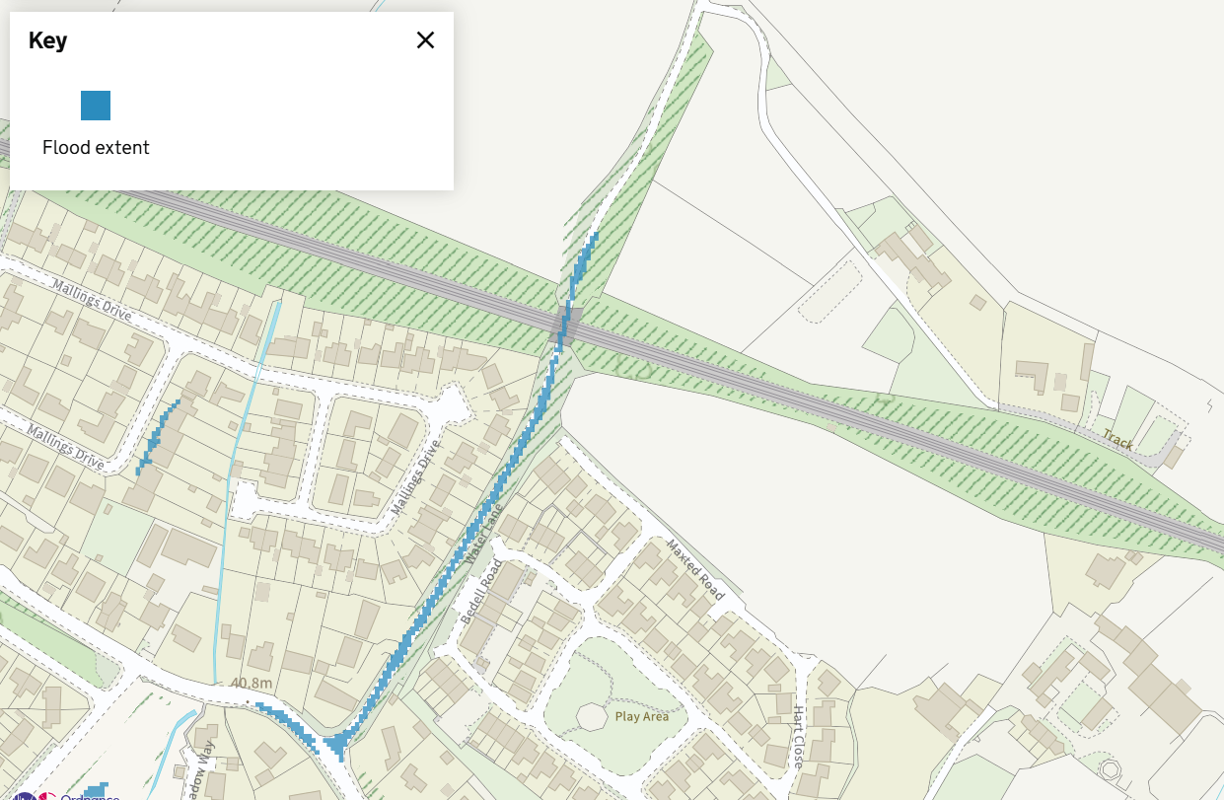
These flood events are also often extreme as illustrated by the photographs below, placing any additional occupants at The Lodge at heightened risk, whilst the provision of a new access point onto the Lane would also likely serve to only increase the existing flood risk.
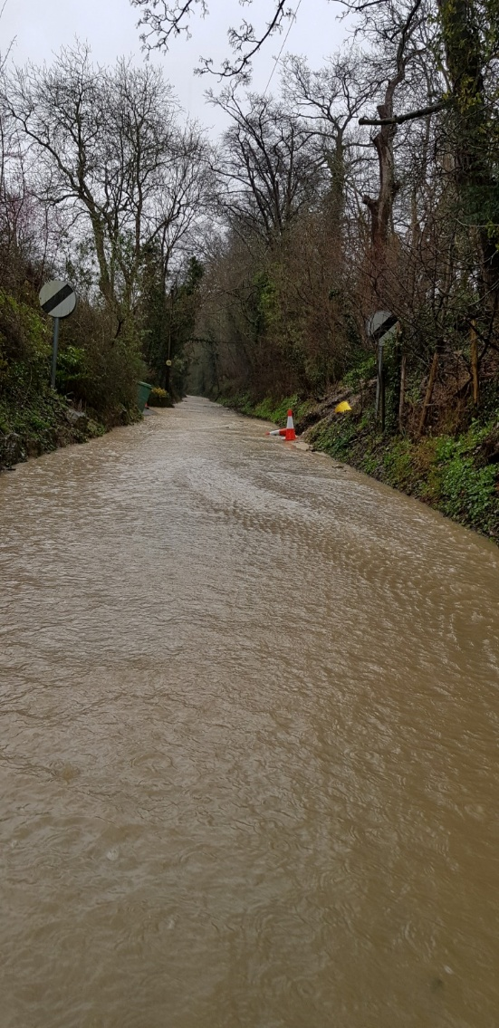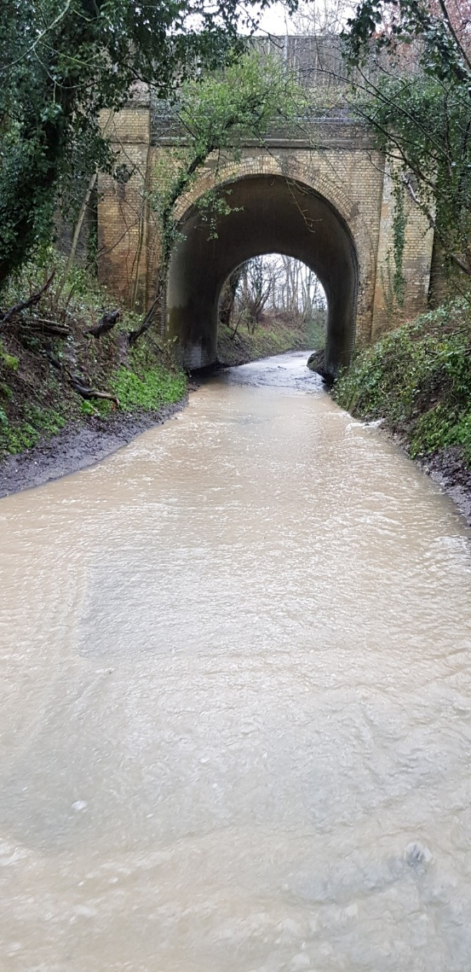
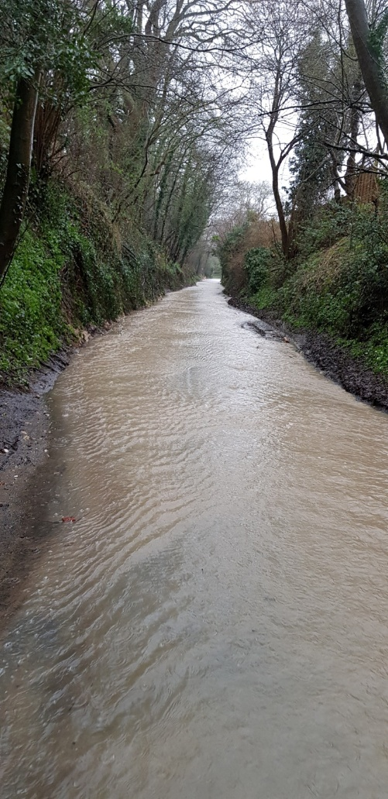

With all of the above constraints in mind, we refer to the accompanying access plan. This demonstrates that the best achievable visibility splay at the junction is a mere 2.4 x 14m to the north, and 2.4 x 29.5m to the south. Both fall significantly and alarmingly short of the applicable Manual for Streets standards for the 60mph speed limit and would be the case even if the protected tree was disregarded (which it can’t be).
Using the visibility calculation set out in Manual For Streets, a visibility splay of 14m equates to a design speed of 12mph. Experience indicates that traffic is travelling considerably in excess of this speed when approaching from the north an a such would not be acceptable.
Based on onsite observations we would suggest that the 85%ile speed would likely between 30 and 40mph which would equate to visibility splays of between 43 and 82m. As demonstrated on the drawing it has been demonstrated that these visibility splays could not be provided with land either within public highway or land under their control.
Given the above and enclosed, it is unequivocally clear and unarguable that the proposed access is unsafe and falls significantly short of the applicable design standards prescribed by Manual for Streets. Allocation of this site would thus be in direct contravention of NPPF paragraph 116, given that there would be an unacceptable impact on highways safety. There is no evidence currently before the Council that could possibly suggest otherwise and KCC alarmingly are yet to even assess the site in their capacity as local Highway Authority.
These clear safety issues are only compounded by the nature of the proposed allocation. As a gypsy & traveller site, it can be expected that the access will be used by slower, larger vehicles often towing. This makes the need for a safe access with sufficient visibility essential.
The Council’s Sustainability appraisal scores the site as ‘Minor Negative’ for Transport and Accessibility, however it is clear from the above that this scoring is not supported by the evidence and the correct score should be ‘Major Negative’. Using the Council’s own scoring methodology, the unacceptable highway safety impacts cannot be mitigated.

- Sustainability
As has been established above, the site in question is unable to provide a safe vehicular access. Access for pedestrians is also inherently unsafe and incapable of mitigation – Water Lane comprises a narrow, single carriage rural lane with national speed limit and a fast speed environment. There is no footway and no lighting, meaning any pedestrian trips southwards towards Bearsted would put pedestrians at significant risk. As such, the site does not afford realistic opportunities for safe non-car travel to everyday services and cannot be considered a sustainable location. In this regard, its allocation would be contrary to the NPPF and paragraph 13 of the government’s Planning Policy for Travellers.

- Landscape Impact
The Lodge site lies in very close proximity to the Kent Downs National Landscape, which sits immediately north of the M20. At present, there is no detail around the number of pitches proposed and/or the extent of any associated infrastructure and support buildings. As such, it is not possible to undertake a meaningful assessment of landscape impact or come to any conclusion on whether or not allocation of the site would fulfil the Council’s duty under Section 85 of the Countryside and Rights of Way Act 2000 (CRoW Act 2000) to have regard to the purpose of conserving and enhancing the natural beauty of a National Landscape, further cemented by the Environment Act 2021.

- Deliverability
It has been demonstrated that the site is unable to provide a safe access and does not have any rights over the existing Bridge Farm access for future gypsy and traveller development. As such, the site is confirmed as undeliverable and cannot be relied upon (irrespective of its unsuitability) to make any contribution towards meeting the Council’s gypsy & traveller sites need.
It is notable that the Council themselves are yet to conclude that the site is in fact deliverable. The SLAA concludes that “The site's deliverability will be subject to further detailed assessment of the site prior to publication of the Regulation 19 version of the Plan”.
The proposed site would also not be able to deliver the services stated in their application. Currently both properties are served by a ¾ inch water pipe from the mains supply in Crismill lane (east of the properties). This pipeline is owned equally by both properties and would not be sufficient to service additional dwellings and would therefore require the installation of a new supply. Currently both properties have private drainage and given the location of mains drainage it would not be practical / possible to connect to these. Neither property is connected to a mains gas supply. While there is gas pipeline within neighbouring farmland, this pipeline does not serve local gas supply.
We also note that the application by The Lodge states that states there are no covenants on the property. This statement is incorrect given the covenants that are within the title deeds of The Lodge regarding their access and restriction of any building / development being directly limited to that of the existing dwelling.
Conclusion
In summary, it has been demonstrated that The Lodge draft allocation site:
- Is unable to provide an access which is safe, with achievable visibility falling significantly short of the applicable standards, even if unrealistically slow average speeds are assumed.
- The access is severely constrained by existing protected trees, would add traffic to an unsuitable and narrow rural lane, and would likely add to existing surface water flooding that already blights the road.
- There is no available evidence to suggest the proposed access is safe, no proposed access design and no evidence that it has been properly assessed by the local Highways Authority.
- The location is unsustainable and unable to provide safe pedestrian access to local services.
- Insufficient information is provided to be able to conclude that allocation of the site would conserve and enhance the landscape and scenic beauty of the nearby National Landscape.
- In the absence of being able to provide a safe access, the site is undeliverable

Allocation of the Lodge would therefore be in direct conflict with the overarching sustainable development aims of the NPPF, is unsuitable and undeliverable and as such should not be progressed as an adopted site allocation. Allocation of the site would render the DPD unsound, contrary to NPPF paragraph 36:
- Unjustified – allocation of the site is not appropriate when faced with the clear evidence relating to woefully inadequate access visibility and highway safety;
- Ineffective – in the absence of safe access, the site is undeliverable and thus not effective.
- Inconsistent with national policy – the access would result in unacceptable impacts on highway safety, the site is unsustainable and it is not proven that its allocation would conserve and enhance the National Landscape. Accordingly, its allocation would be wholly inconsistent with the NPPF and national policy, including the Planning Policy for Travellers.

We trust our representation will be given due consideration and would request that the Council ensure the views of Kent Highways are sought as part of the consultation process. It is imperative that Officers and KCC Highways both visit the site to see first-hand how significantly constrained the proposed access is in terms of visibility, and we would be happy to meet Officers on site if helpful,

Kieran and Emma Burns

